Year 8 Earth Science – Pre-test Name: ____________________

This is a pre-assessment of your current knowledge of the content you are about to learn.

Make sure you read the questions carefully, and attempt all questions.

Write as much detail as you can.

What do you think minerals are made of?

_________________________________________________________________________________

True or false: Minerals and rocks are the same.

* True
* False
* Not sure

What are some everyday uses for rocks and rock materials?

_________________________________________________________________________________

_________________________________________________________________________________

Where do rocks and minerals come from? Select all the options you agree with.

* Both rocks and minerals come from the ground, below the Earth’s surface
* Rocks come from the ground, but minerals are man-made
* Rocks can be compacted sand and soil
* Minerals are made from rocks
* There are many different types of rocks and minerals, and they are all made differently
* Rocks can take millions of years to form
* Minerals are made very quickly
* Some rocks are made from cooled magma and lava
* Rocks and minerals cannot be changed over time

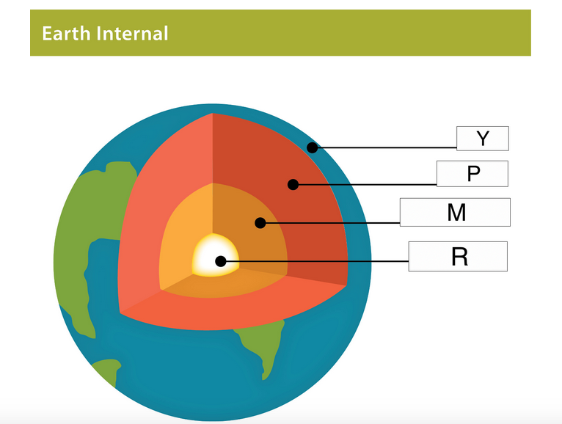

Using the image above, what is the name of the layer Y?

* Land
* Ocean
* Crust
* Mantle

Using the image above, what is the name of the layer P?

* Lava
* Magma
* Core
* Mantle

The inside of the Earth is extremely hot, molten (liquid) rock... True or false?

* True
* False
* Not Sure

Features of rocks

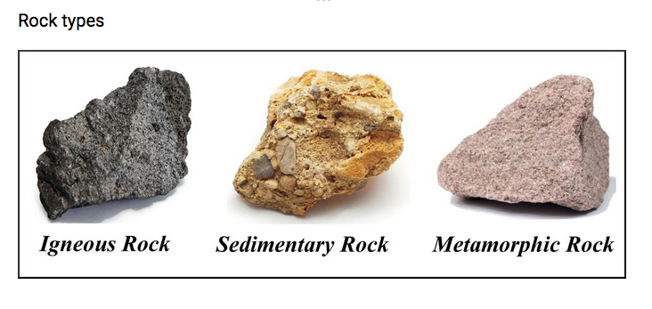

Using the image above, what are some similarities between the rocks?

_________________________________________________________________________________

_________________________________________________________________________________

Using the image above, what are some differences between the rock types?

_________________________________________________________________________________

_________________________________________________________________________________

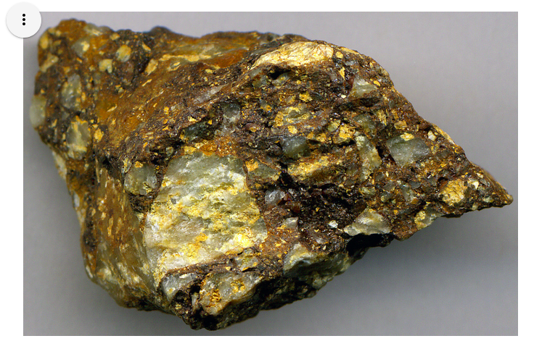

Using the image above of the rock types, what would you classify this rock as?

* Igneous
* Sedimentary
* Metamorphic

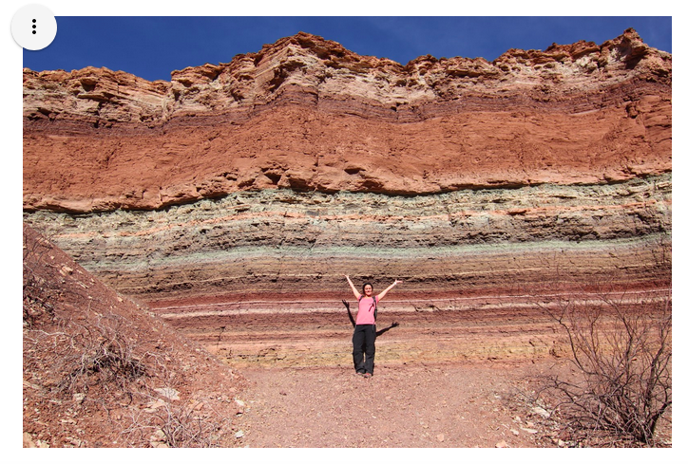

Look at the image above, what do you think caused it to form different coloured stripes?

_________________________________________________________________________________

_________________________________________________________________________________

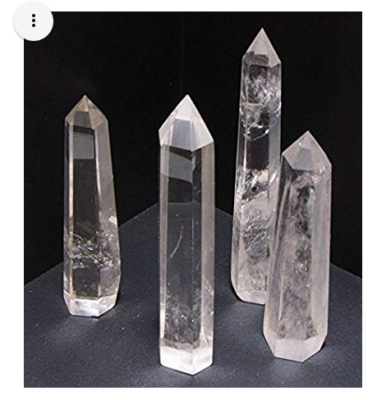

The image above is a Quartz crystal. How do you think they were formed?

* when liquid rock cools slowly and start to harden
* A mix of chemicals that harden over time
* A particular type of rock was compressed
* They are not made in a rock, they are man-made